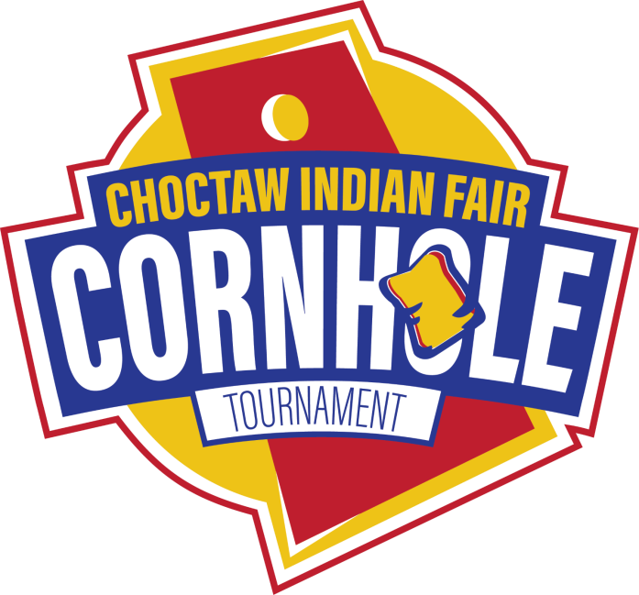
Tribal Member Cornhole Tournament Registration Form

COMPETITIVE DIVISION
Date: Friday, July 17, 2026, from 10 AM – Until
Time: Sign-in/warm-up - 10 AM / Tournament - 11 AM Entry Fee: $40 for two-person team Eligibility: Must be Tribal Affiliated
Cash prizes for 1st, 2nd, and 3rd Place teams! 1st- $800
2nd- $600
3rd- $400
DEADLINE TO ENTER: Friday, July 10th, 2026, by 03:30 PM. Entry Fee goes up to $50 after the deadline.
E-mail completed form to kevin.grisham@choctaw.org. Please pay at Finance Window. Turn in receipt and copy of completed registration forms to the mailroom drop-off window at the Tribal Office.
Walk-up registrations will be accepted on the Day of Tournament.
Team Name: __________________________________________

 | Player #1 |  | Player #2
Name |  | Name
Date of Birth |  | Date of Birth
Address |  | Address
Cell Phone |  | Cell Phone

This is a friendly competition and decisions by the Cornhole Committee are final. We expect the honor system for score keeping by all teams. By signing below, you agree to the rules and requirements.

Player #1 Signature: ___________________________ Player #2 Signature: ___________________________
Pursuant to Title XXXII (32) of the Choctaw Tribal Code, sex offenders are prohibited from being in any school building or on real property comprising any school.

